Free Youtube views for an unlimited number of your videos! Boost your video's popularity using their simple and free method! Or, buy Youtube views and other services here.

[ythunder.com](https://ythunder.com/) has free & open registrations.

Getting people to subscribe to your [YouTube](https://ythunder.com/) channel can look like a daunting task, but there are a lot of little ways to attract them. Here some of the tricks you can pull off to get free [YouTube subscribers](https://ythunder.com/).

Create great [YouTube](https://ythunder.com/) contentFree Youtube views：[ythunder.com](https://ythunder.com/)

Attracting subscribers begins with having engaging videos, and one of the ways to create them is by having good scripts. Write your scripts in a tight manner to keep the video moving at a brisk pace. Make sure that you include all the important details to guide you when filming. The DIY channel Make has videos which are an example of how a good script will improve the watchability of your content.

The clear dialogue in their tutorial videos helps make even the complex steps easier to follow, and that can only be achieved by the host knowing what he’s going to say in advance with a well-prepared script.

Look at your audience data to find out when videos have a dip in viewership and review their scripts. This will give you an idea of how to refine your next one. Read it out loud to get an idea of how it will sound to your audience and revise accordingly.

Edit your videos thoroughly

When editing your videos, remove all distracting moments, Free Youtube views：[ythunder.com](https://ythunder.com/)

such as long pauses and off-tangent talk. Numberphile’s video below demonstrate how this helps make the content’s flow easier to follow.

Make it more pleasing to your audience’s eyes by adding transitions and visual effects in the right sections. The above video showcases this with the transition texts that catch the attention of viewers.

Translate your videos

Translating your videos into different languages is an effective tactic to attract more foreign subscribers. If you can speak another language, record a track in that language and add it to a version of your video for native speakers. You can also write subtitles, like what Korean pop band BTS did to popularize their “IDOL” music video with English-speaking fans.

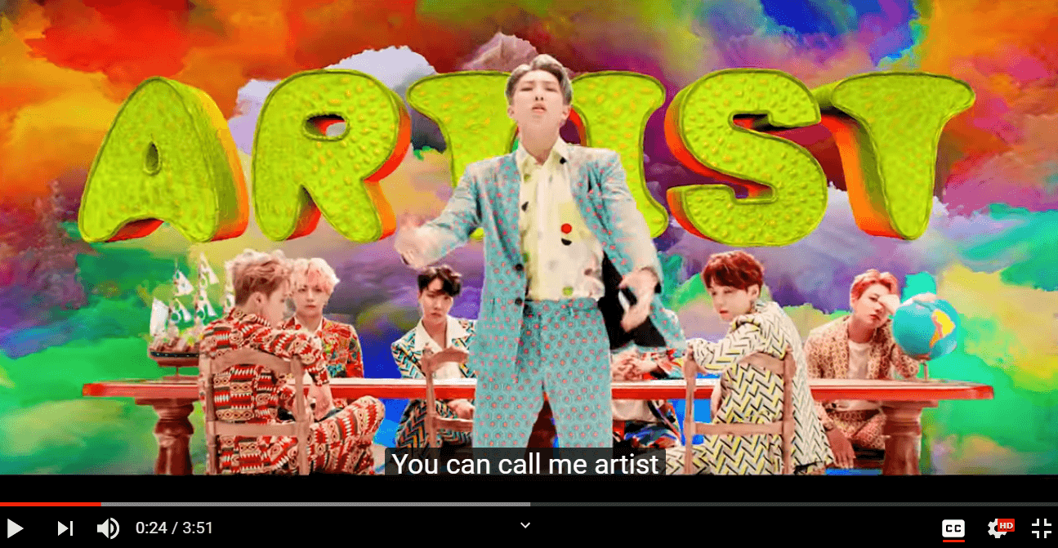

Some of your fans might even be willing to do the subtitle translations for you and share this content with you to upload.

Create a consistent publishing schedule

People are more likely to subscribe to your channel if they know when your next video is coming out. Create a publishing schedule that matches your audience’s viewing habits. Don’t forget to remind them about the schedule by mentioning it in your videos and other places on your channel. Encourage them to subscribe for updates.

Encourage binge watching through playlists

Another good tactic to get free [YouTube subscribers](https://ythunder.com/) is by having them watch more of your videos in one go, giving them longer to hit the subscribe button. Create a variety of playlists to organize your content and help viewers find which ones to watch.

When sharing your videos, use a link from within the playlists. This ensures that those who click will see the other entries immediately, getting you more views and more opportunities for them to subscribe.

Create content for mobile devices

When creating content for mobile devices, make your video’s convenient to watch on different devices. For example, you can shoot in a square format to let people watch without having to re-orient their devices. Buzzfeed’s Tasty channel is well-known for using this format, which fits their on-the-go cooking videos.

Interact with your viewers the right way

If you want to get free [YouTube subscribers](https://ythunder.com/), interacting with your fans will help convince them to follow the channel. Actively respond to their comments on your videos to show that you do read them. Aim to strike up an ongoing conversation with them in the comments section.

You can take this approach a step further by asking for comments during your videos. Respond to them in your next video so that your viewers will be enticed to subscribe just to see if their comments get picked up.

The Pedal Show, a guitar enthusiasts’ channel, does this in a lighthearted manner from time to time.

Feature your viewers

Featuring your viewers in your video is another good tactic to get them invested in the channel. Ask them who would want to be a part of your next video. You can also use your live videos for this purpose by encouraging viewers to leave live comments, then reading them while on air. Do this frequently to push viewers to subscribe so that they can one day have their comments addressed live.

Ask them to subscribe

Asking people outright to subscribe to your channel is a simple way to get them to do so, but you need to have a strong hook to convince them. Tell them about the new things they can expect to learn from the channel. Present your hook in an engaging channel trailer and add your call to action at the end of it, like what Will Smith does for his channel trailer.

Another time to ask for subscribers is during end credit scenes. Use an auditory call to action along with a [YouTube](https://ythunder.com/) end card, and do it at the end of every video, to build your subscriber numbers with each video people watch all the way through.

Turn viewers into channel ambassadors

Your viewers can themselves be effective at attracting more free [YouTube subscribers](https://ythunder.com/). Go through your comments section to find out who are frequent commenters. Reach out to them and convince them to become channel ambassadors. Sharing exclusive content with them is one way to get them to agree.

Create video responses

Take a look at popular videos within your niche and create a video response for some of them. Aim to add more information than the original video was able to cover, or provide entirely new ideas for the creator.

Conan O’Brien does this in a quick-witted but light-hearted manner in his responses to popular videos.

Share the response to the video creator. If they like what you have, they will share it with their audience and encourage them to subscribe to your channel.

Promote your channel vigorously

Social media gives you a lot of opportunities to get plenty of free [YouTube subscribers](https://ythunder.com/). Take advantage of it by talking about your channel on your other social media pages. Share clips of your videos, behind-the-scenes content, and bloopers to whet their appetites and get them to your channel from the social media site so that they can subscribe.

A nifty trick when sharing your channel on social media is to use sub confirmation links. These links have the suffix “?sub_confirmation=1” at the end of the regular channel URL, like this:

**https://www.**[**youtube**](https://ythunder.com/)**.com/channel/UCVcLXmRcoBThv4vhVETjozA?sub_confirmation=1**

When your social media followers click on the link, a pop-up box appears, asking them if they want to subscribe. Using such links makes it easier for them to follow the channel.

Promote in niche communities

Reaching out to online groups that are relevant to your channel lets you discover new audiences. Social media-based groups are the most common ones to go after, but you can also visit other online communities, like this one on Reddit.

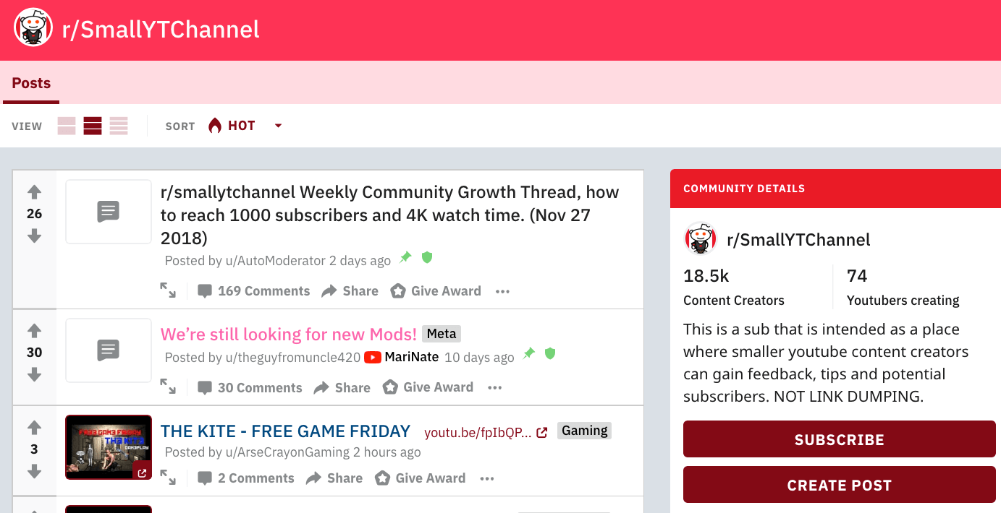

Feel free to solicit some suggestions from your viewers about the online communities they frequently visit and promote on them.

Collaborate with other channels

When planning a collaboration with other creators, look for a channel that is similar in size to your own. They are often more than willing to team up since they get the same gains as you. Talk about what new things you can offer for each other’s audience and use this as a central theme for your collaboration videos. VSauce does this frequently for the various collaborations they work on with other creators, likes this one:

Don’t forget to tell your respective audiences to check the other channel out and subscribe.

Engage other channels at leisure

Becoming a viewer yourself and engaging with the channels you are personally interested in can be a surprisingly effective way of getting subscribers. Comment on their videos and share your own knowledge with your fellow viewers. This gives you the opening to get them and even the channel owner to check your content and subscribe.

A tactic used by PewDiePie, way back when he had no subscribers, was to DM fans of other channels and get them to watch and subscribe to him. This low-key tactic worked, and can still be used to build a gaming channel.

Encourage people to share your videos

Don’t limit your content only to social media sharing. Enable video embedding and encourage your followers to share your content on their websites. This helps spread your videos to more places where they can be seen by potential subscribers. Catch people’s attention by ending your embedded video with a teaser of what they can find on your channel and a call to subscribe.

Gain tons of free [YouTube subscribers](https://ythunder.com/) with these tactics

Attracting more free [YouTube subscribers](https://ythunder.com/) is one of the major steps in your channel’s growth. To get people subscribing, you should:

* **Have great content:** Plan your videos to make them easy to understand. Use mobile video and let your viewers watch your content wherever they are.
* **Interact with your audience:** Start a conversation with your viewers and feature them in your videos. This will get them invested in your channel and ready to subscribe.
* **Promote, promote, promote:** Spread the word about your [YouTube](https://ythunder.com/) channel to different places online and engage with the new viewers that will be coming in.

Use the tactics that we have listed here, along with other techniques to increase your viewership, and you will be your way to becoming the next big hit on [YouTube](https://ythunder.com/).

Next

PreviousFree Youtube views for an unlimited number of your videos! Boost your video's popularity using their simple and free method! Or, buy Youtube views and other services here.

[ythunder.com](https://ythunder.com/) has free & open registrations.